**Modern Hexagons Wall Shelves**

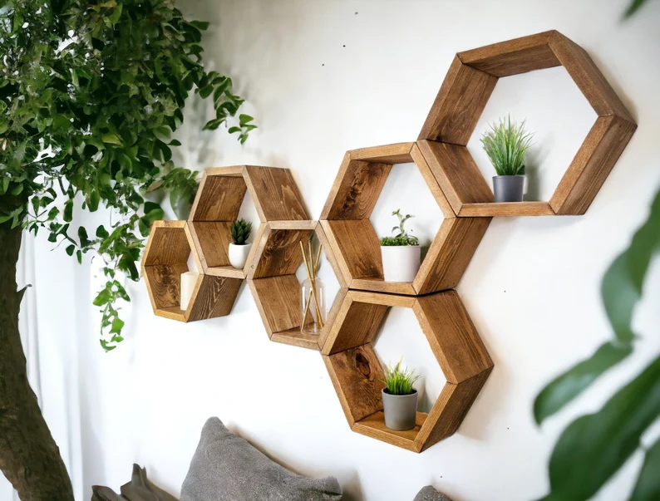 Modern Hexagon Wall Shelves are a trendy and geometric shelving solution that adds a contemporary touch to any room. Shaped like hexagons, these shelves create a striking visual effect when arranged together or placed individually. Typically made from wood, metal, or a combination of both, they offer a stylish way to display books, plants, or decorative items while saving space. The hexagonal design is perfect for modern, minimalist, or industrial interiors, offering a unique alternative to traditional shelving. Whether installed in living rooms, bedrooms, or offices, Modern Hexagon Wall Shelves combine both form and function to enhance the look of any space.